The Examiner DECEMBER 6 2019 - 12:36PM

Tony Newport's album 'This Land' is deeply Tasmanian folk

Frances Vinall

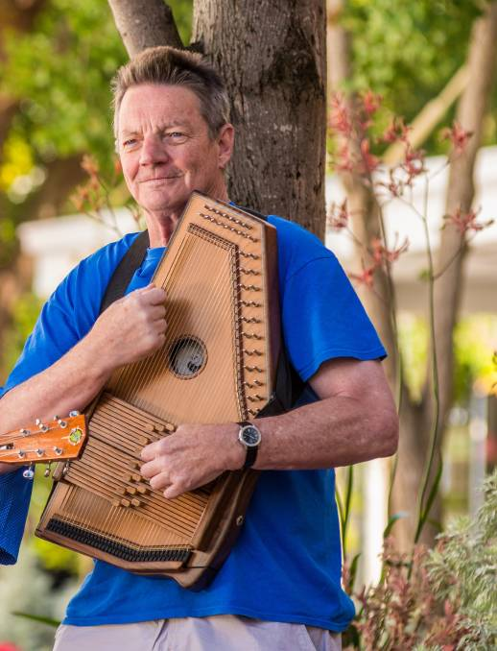
Hillwood musician Tony Newport's album, This Land, is filled with little glimmers of recognisable references.
There are children "on their way to school at Strahan", a song named the Pieman River Rag, and references to buttongrass and dark-stained water.

Tasmanian ears will be unable to avoid perking up during even a casual listen.
As with his first album, Give Me Grace, This Land draws heavily on the West Coast for inspiration.
Newport grew up there and spent about 20 years at Rosebery, employed as the Australian Workers' Union secretary at the base metal mine.
He describes the coast as "rich in minerals and rich in material".
And as with most folk music, This Land is strongest when evoking the deep specific minutiae of a particular place and experience - rather than making general platitudes like, "we are all the same".
Teaching in the Tanami is one example, a lovely listen in the folk tradition of imbuing a standard place name with mystery and romance. In this case, didgeridoo and clapping sticks float in the background, as Newport tells the story of a simple conversation with a woman on a plane.
Newport said he had that conversation over 20 years ago, and it has remained with him ever since - waiting to be turned into a song.
FIFO is a highlight, a moving track about the loneliness of Fly In Fly Out life for modern miners.
"The life is crap but the pay is great," Newport sings. "Ain't life fun when you're doing time | And the best of you has gone to the mine".
This is underscored with Celtic strains that sound like a fresh breeze and endless green hills - the opposite of the dirty, claustrophobic life described, and an effective songwriting trick.
The track was inspired by his feeling that something has been lost in the new mining model.
The life he knew growing up in Rosebery is "all gone now," he said.
"The way the mining industry has changed with technology has completely changed those communities," he said.
"Because were so isolated, the community was everything. Everybody knew everybody, and I can't remember a sporting contest ever being cancelled down there - no matter the weather."
The album was made with session musicians, and Newport said their input completely transformed the songs.
"I don't get sit in with the session musicians, I let them go, I let them do whatever they like," he said.

